BidForge - Complete Application Documentation
By Nandeesh Kantli
RV University
1RVU22CSE109
nandeeshak.btech22@rvu.edu.in | nkantli24@gmail.com

This is the master product + technical document for the current BidForge build.
Terminology used in this document:
- RFQ Owner = procurement owner who creates and manages RFQs.
- Bidder = supplier/carrier who participates in auctions.

1) Product Overview

1.1 Problem
Procurement teams need transparent price discovery with strict close control, while suppliers need fair live ranking and quick bid revisions.

1.2 Solution
BidForge provides:
- Role-based auction workspace (rfqowner, bidder).
- Reverse-auction RFQ lifecycle with start/close/forced-close windows.
- British-style extension logic with configurable triggers.
- Real-time updates (status, bid rank, extension events).
- Awarding, exports, timeline, and analytics.

2) System Architecture
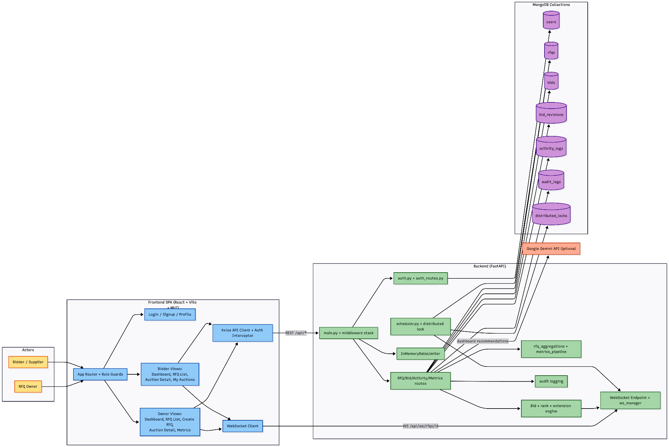

3) End-to-End Role Flows

3.1 RFQ Owner (Buyer) Flow

Screen flow
- Login/Signup -> stores token and role in local storage.
- Dashboard -> sees total/active/upcoming/closed RFQ cards, close-time risk, and recommendations.
- Auctions (RFQ List) -> filters, search, sort, pagination, and extension-aware notifications.
- Create RFQ -> enters timeline, extension config, visibility mode, starting/decrement pricing, and optional file metadata.
- Redirect to Auction Detail after creation.
- On Auction Detail, can:
  - edit auction (when allowed),
  - pause auction (restricted window),
  - export bids/activity CSV,
  - monitor bids and activity timeline,
  - award winner after closure.
- Metrics -> chart-based analytics and paginated metric tables.

API flow
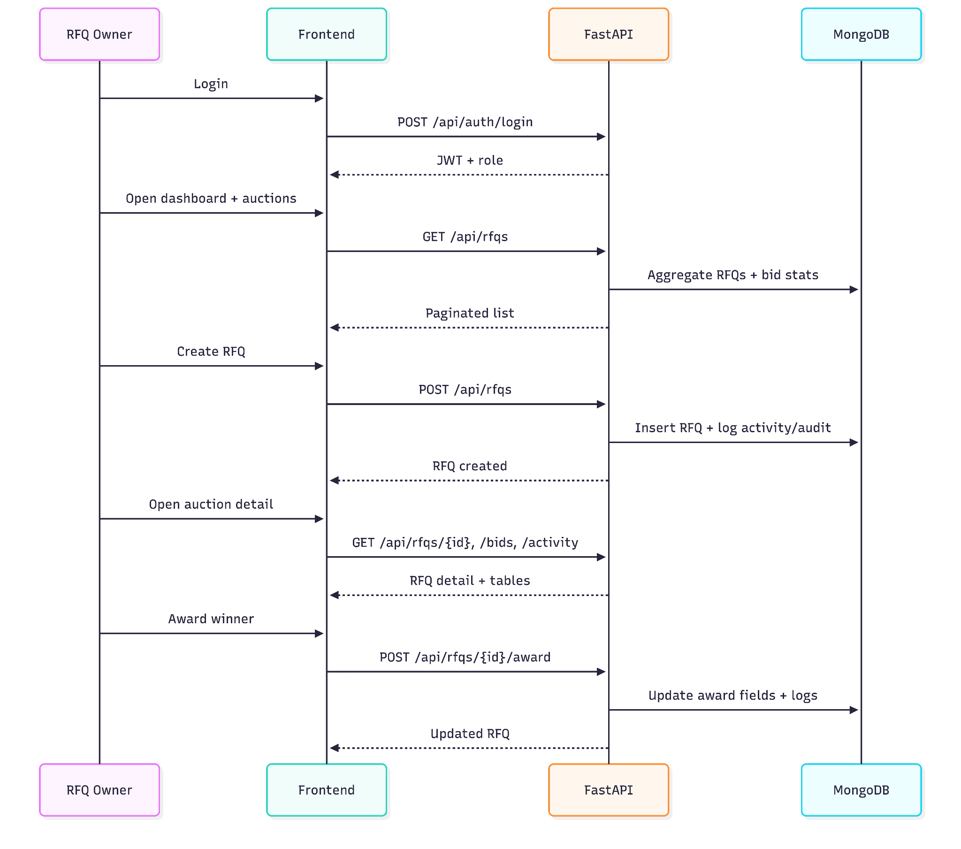

3.2 Bidder / Supplier Flow

Screen flow
- Login/Signup as bidder.
- Dashboard -> sees participated auctions, active bids, L1 rate, Top-3 rate, and risk insights.
- Auctions (RFQ List) -> browse active/upcoming/closed auctions with live countdown.
- Auction Detail:
submit/revise bid while active,
see own quote details,
competitor data is masked as per role rules,
receive live updates over WebSocket.
- My bids page -> focused view of auctions where bidder has participated, with rank and L1 comparison.

API flow

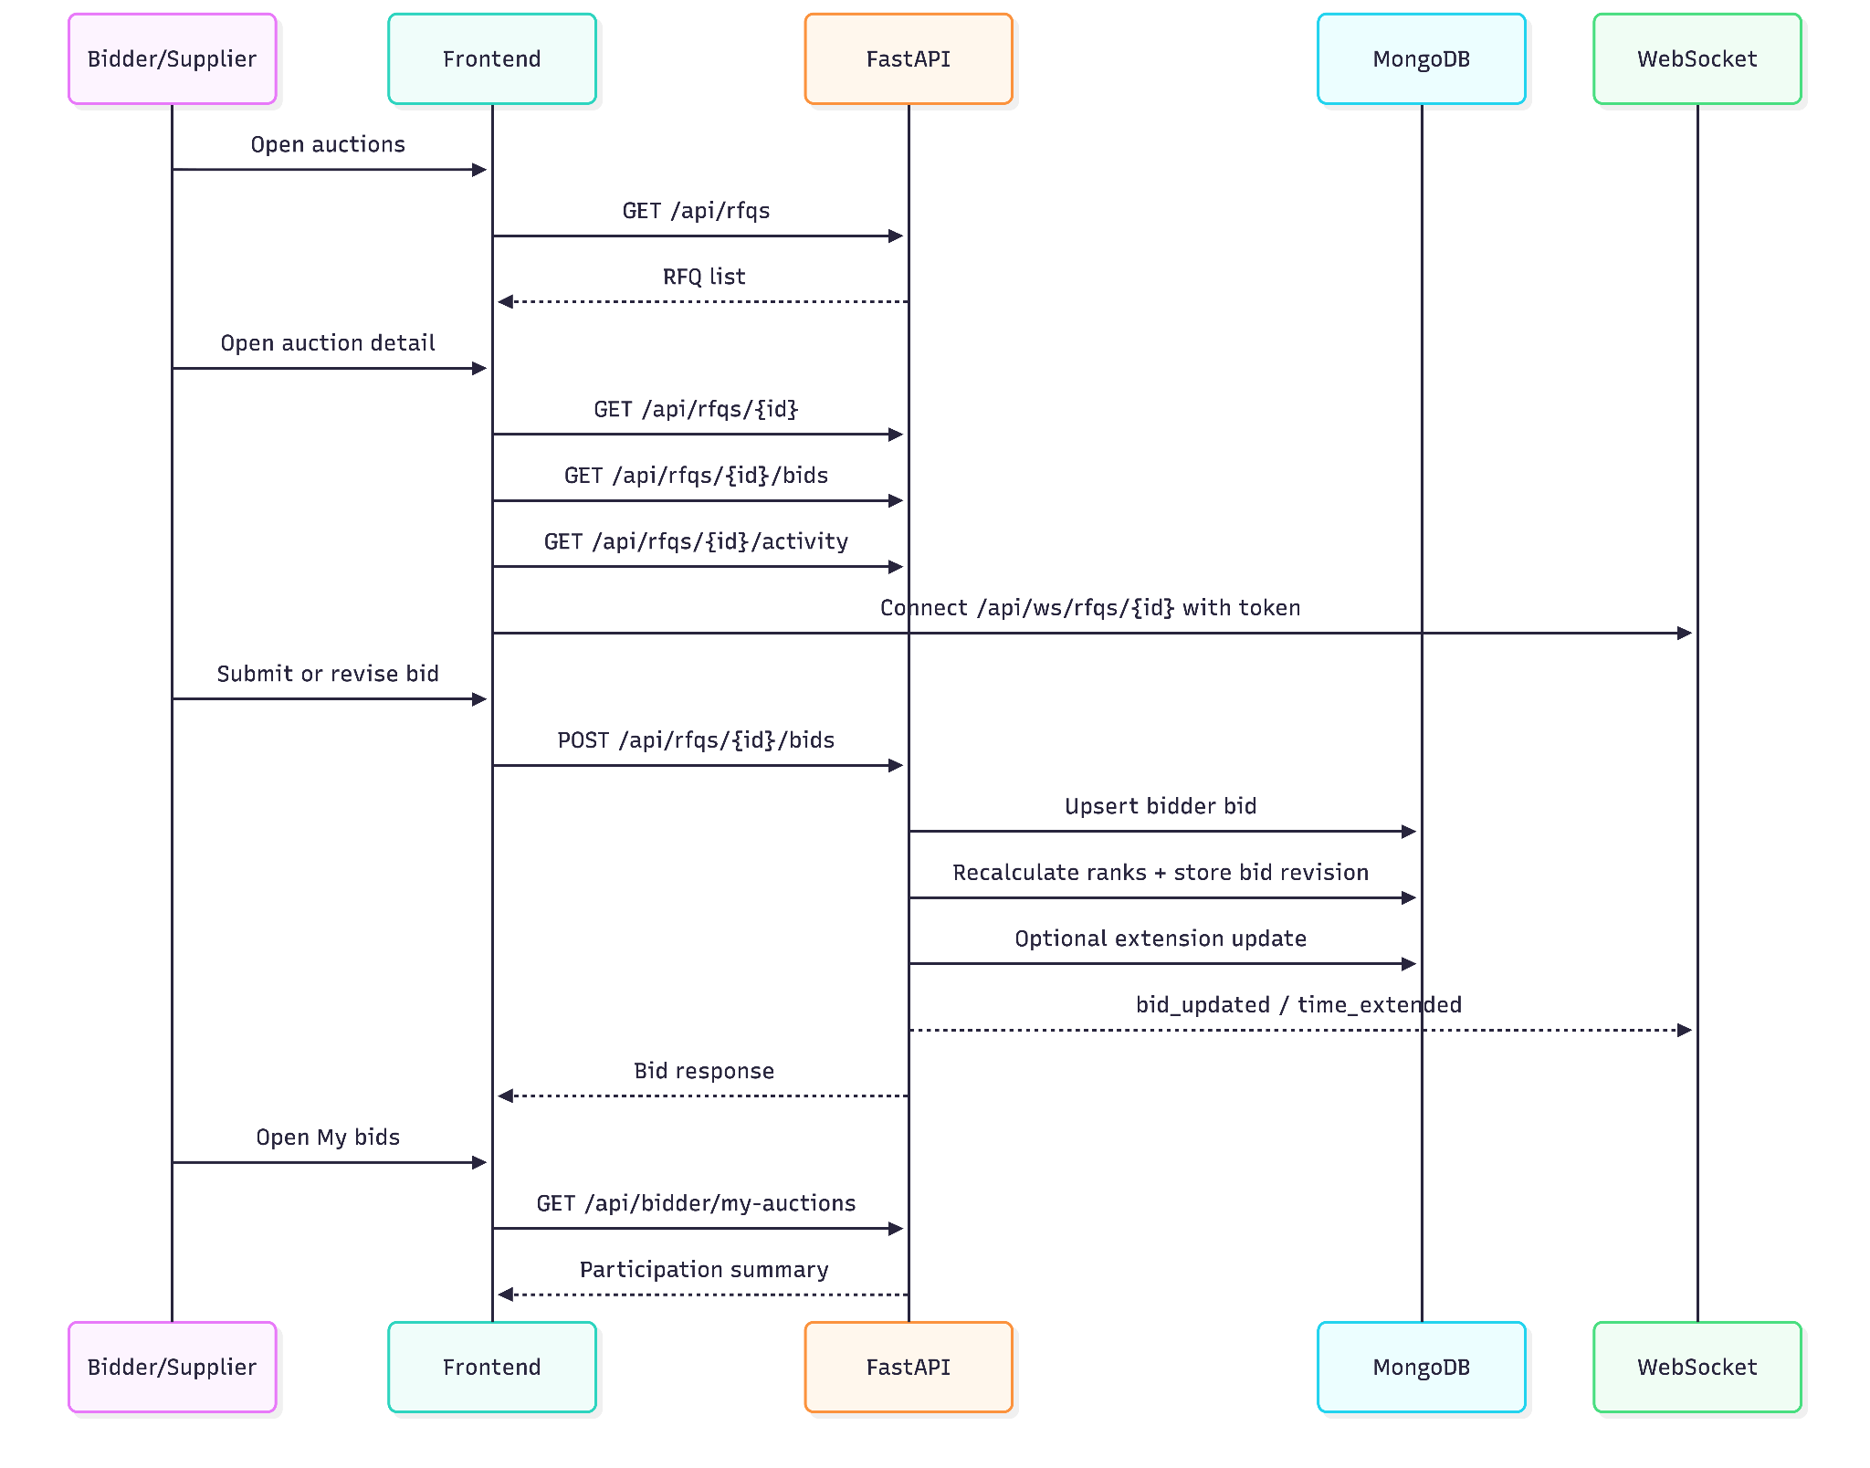

4) Core Auction Lifecycle
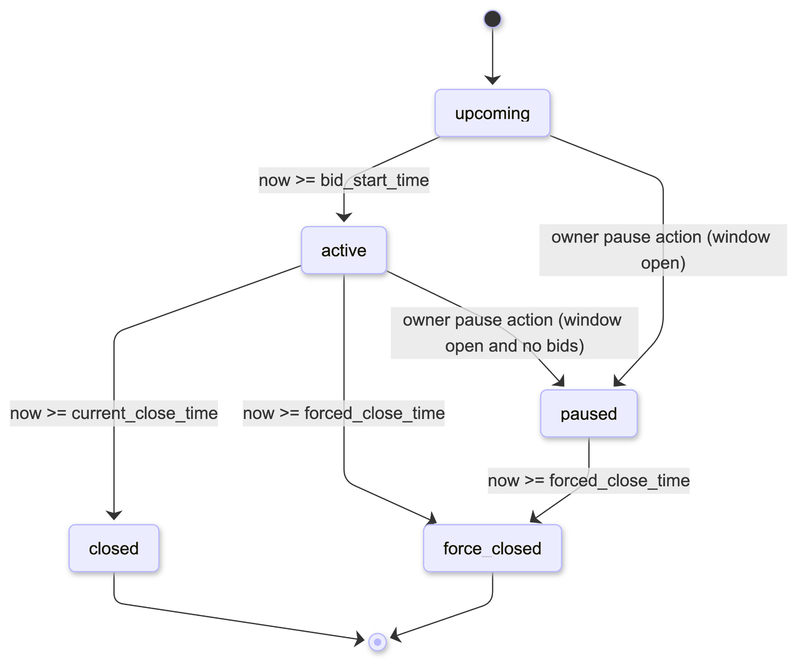

Notes:
- Scheduler persists status transitions periodically.
- Detail/list endpoints also compute status in real-time.

5) Bid and Extension Engine

5.1 Bid submit/revise logic
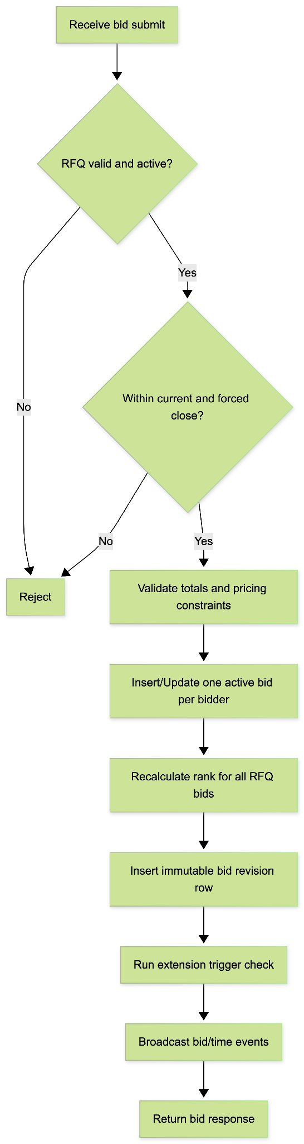

5.2 Extension logic
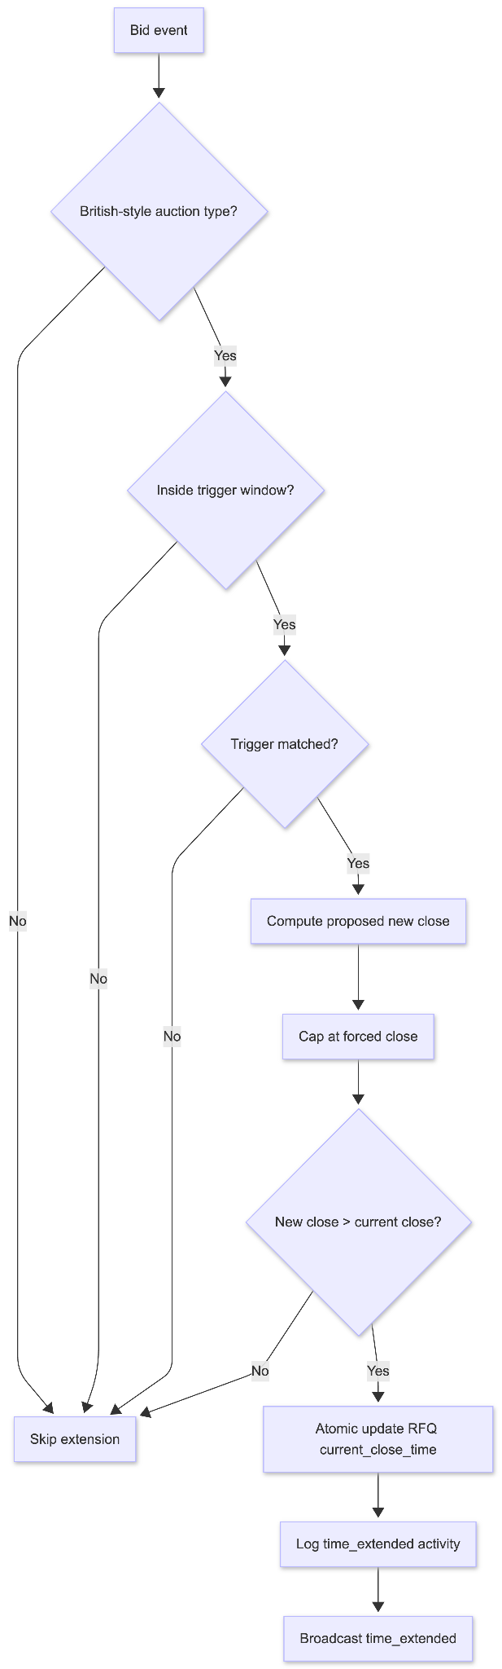

6) Data Model (ER)
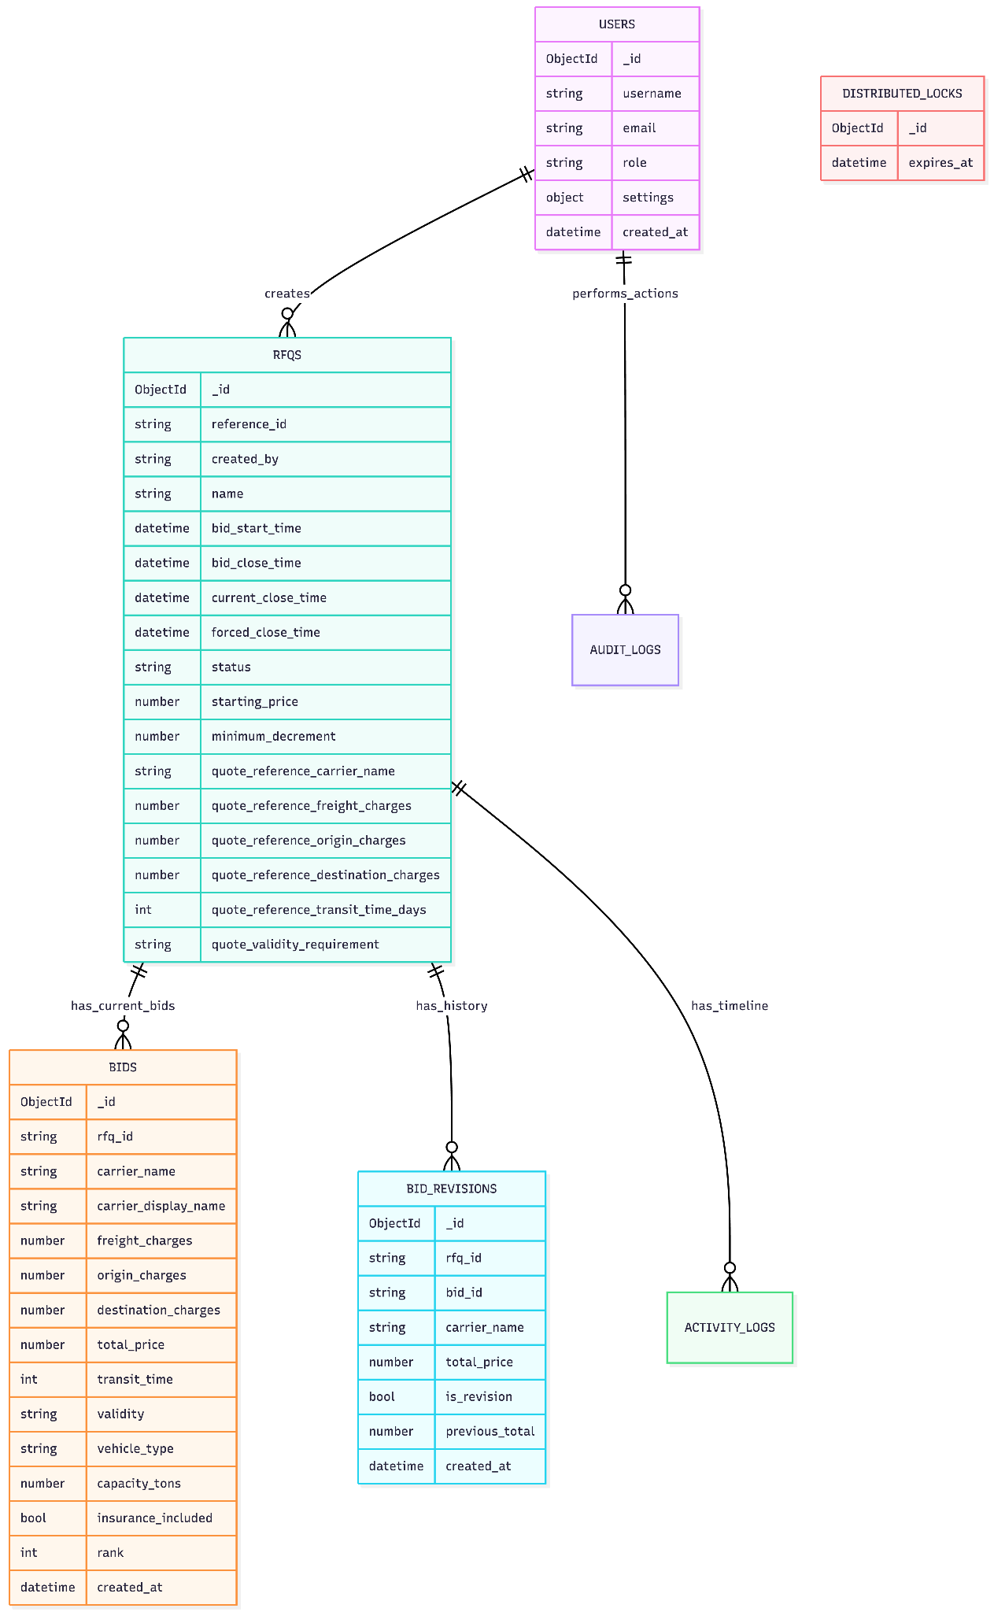

7) Frontend Module Mapping
- Dashboard:
  - owner: RFQ participation, close pressure, recommendations.
  - bidder: rank health, top-3 rate, risky closes.
- RFQList:
  - auto-refresh, search/filter/sort, status cards, countdown.
- CreateRFQ:
  - time and pricing validations before submit.
- AuctionDetail:
  - bids table, timeline, websocket updates, edit/pause/award controls.
- SupplierMyAuctions:
  - bidder participation tracker with countdown and rank.
- BuyerMetrics:
  - trend charts and paginated metric tables.

8) API Surface

Auth
- POST /api/auth/signup
- POST /api/auth/login
- GET /api/auth/me
- GET /api/auth/settings
- PATCH /api/auth/settings

RFQ + Auction
- POST /api/rfqs
- GET /api/rfqs
- GET /api/rfqs/{rfq_id}
- PATCH /api/rfqs/{rfq_id}
- DELETE /api/rfqs/{rfq_id}
- POST /api/rfqs/{rfq_id}/pause
- POST /api/rfqs/{rfq_id}/award
- GET /api/bidder/my-auctions

Bids + Activity + Export
- POST /api/rfqs/{rfq_id}/bids
- GET /api/rfqs/{rfq_id}/bids
- GET /api/rfqs/{rfq_id}/bids/export
- GET /api/rfqs/{rfq_id}/bid-revisions
- GET /api/rfqs/{rfq_id}/activity
- GET /api/rfqs/{rfq_id}/activity/export

Metrics + Recommendations
- GET /api/metrics/bids-per-rfq
- GET /api/metrics/avg-bids
- GET /api/metrics/winning-price-trend
- GET /api/metrics/extensions-per-rfq
- GET /api/metrics/extension-impact
- POST /api/dashboard/recommendations

Realtime
- WS /api/ws/rfqs/{rfq_id} with subprotocol token auth.

9) Security and Reliability
- JWT bearer auth and role guards.
- PBKDF2 password hashing with legacy bcrypt verify support.
- In-memory rate limits (global + stricter bid submit).
- Request correlation (x-request-id).
- HTTPS enforcement and HSTS in production.
- Scheduler status sync every few seconds with lock control.
- Audit logging for security-sensitive actions.

10) Testing and Validation
Backend test focus:
- auction logic
- auth and role checks
- route hardening
- websocket auth
Frontend test focus:
- auth screens
- auction detail behavior
- metrics/dashboard rendering
Manual checklist:
- owner creates RFQ, edits, pauses, awards.
- bidder submits first and revised bids.
- extension triggers near close are applied.
- exports download correctly.
- winner + timeline + metrics are consistent.

11) Future Improvements
- distributed websocket/pub-sub (Redis).
- distributed rate limiter.
- stronger file storage integration for specs.
- richer bidder anonymization policies.
- notification channels for close/award events.

